Ka-Band for CGSM and THEMIS

Eric Donovan – June 29, 2006

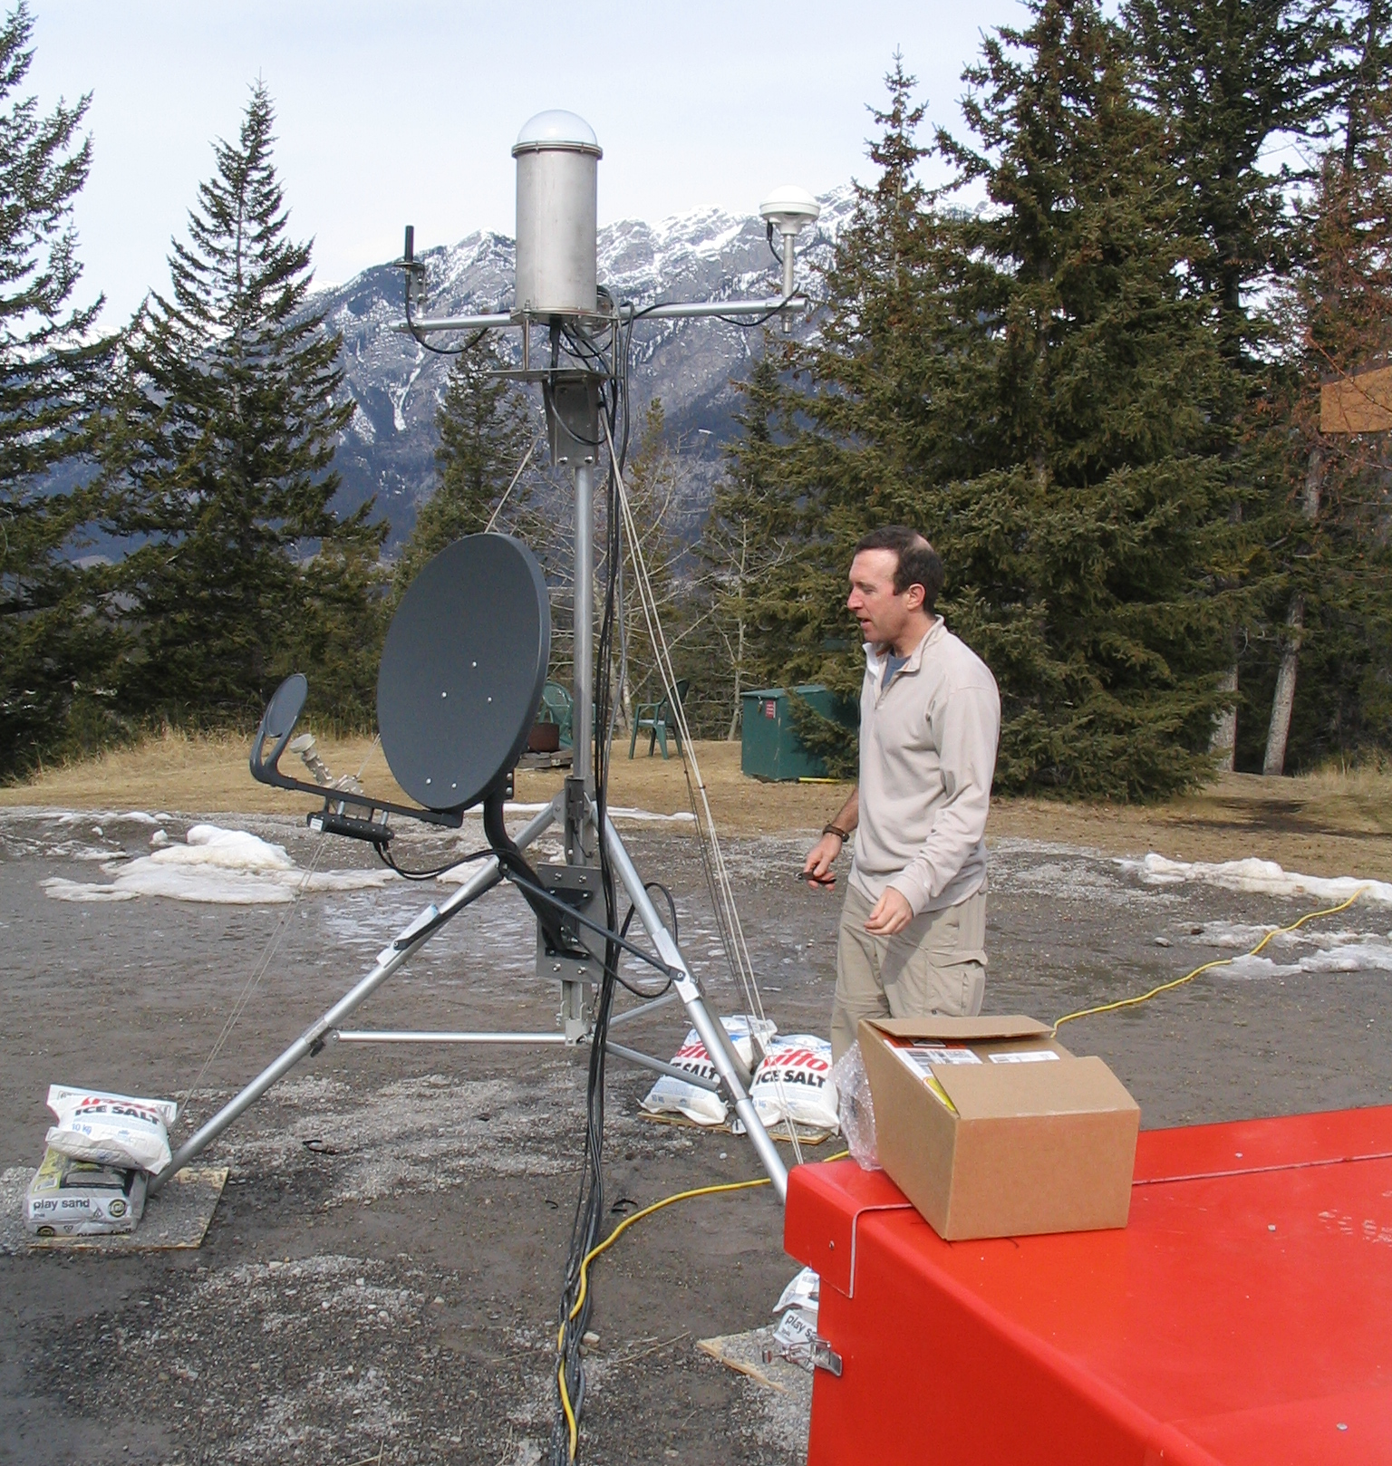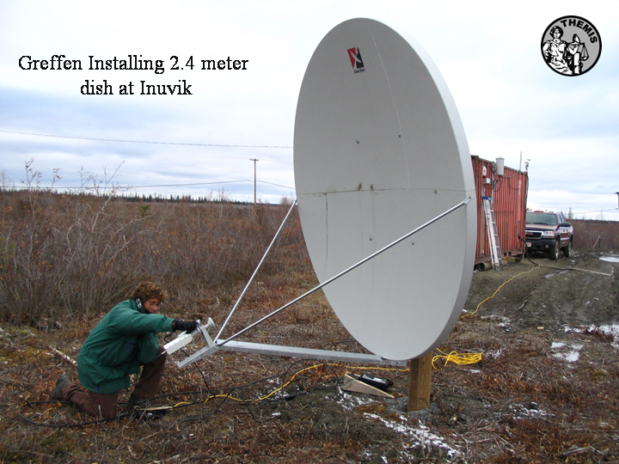

Figure: Left) Tim Quinn from UC Berkeley standing by the THEMIS GBO deployed temporarily at Banff in March 2006. Te grey dish on the trip pointing away from Tim is the 64 cm Ka-Band system marketed as “HSe” by Infosat and “Netkaster” by Netkaster. Right) Mike Greffen installing 2.4 meter HSi dish and electronics at the PolarDARN facility in Inuvik.
To: Christine (Netkaster)

Cc: Bill Gryba, Brian Jackel, Ron Wilkinson, Thomas Piekutowski, John Manuel, Mike Greffen.

Christine – I really enjoyed talking with you today. This will give you a quick idea of what we are up against.

SED Systems (Saskatoon) runs 13 CGSM core sites with HSi installed and operating for Canadian Geospace Monitoring (CGSM). SED will be setting up two or three new core sites next summer. They too need a system that would take the place of the HSi. U Calgary has six THEMIS sites with HSi installed and operating. U. Calgary must install an additional four THEMIS sites this fall, several of would have had HSi systems.

Bill Gryba and Brian Jackel will assess whether Ka-Band meets our needs. Particular issues are the actual bandwidth limits (we need 5-10 kbits per second sustained uplink), whether our central monitoring and data collecting systems can be expediently changed to dynamic IP, and whether you compaby (or any other possibly supplier of Ka-Band systems) will allow us to install and maintain them in situations where it is not practical for us to pay for the supplier to do that.

So you know, SED and our group have been installing and maintaining such systems for years without difficulty. As well, the one advantage Infosat has right now is that they will definitely let us do this if we want to. I agree that you have a lot of towns covered, such as Rankin, and Arviat, and others. However, we want this option, and would use it where appropriate. Also, we are not home consumers, but we are also not a company. SED does work for us – but the bottom line is that this is a science operation, funded to generate knowledge, and we must keep our costs down.

My present understanding is that regarding the Ka-Band system – it costs 750$ from Infosat, 495$ from Netkaster, and in that range from other distributors. That includes the new antenna which is only 64 cm across. This uses dynamic IP, and has no quoted bandwidth limits (just maximum instantaneous bandwidths), but has a “fair use” policy which allows them to throttle users back if they are being bandwidth hogs. Bandwidth caps are high (128 kbits per second for Netkaster’s cheapest package), and you said you expected this system should be able to deliver 10 kbits/second sustained, but will checking that. The cost of service is 59.95$/month for this cheap package, and we can sign up for a one year package. As well – and this is surprising – the Ka-Band system works up to 73.5 degrees geographic latitude (there is a system operating in Pond Inlet), with only a 64 cm dish.

Did I get this correct? As well – how much would installations by your company cost for each of our siites? Can you ballpark that for me quickly? This could be important for several reasons.

To give you an idea of what we are looking at – see the table below. Those marked urgent are sites we must deal with this summer.

Please get back to me ASAP. I cannot speak for the CSA, nor SED, but I get the impression your company has a fair bit to offer. As well, please cc Brian Jackel (bjackel@phys.ucalgary.ca), Bill Gryba (gryba@sedsystems.ca), Mike Greffen (Greffen@phys.ucalgary.ca), and Ron Wilkinson (ron.wilkinson@space.gc.ca). Each has a big interest in us coming up with a viable solution as soon as possible.

Thank you,

Eric Donovan.
Reference Table: CGSM Core Sites & THEMIS GBOs [✓=deployed, =planned].

Name | Abbreviation | Latitude | Longitude | THEMIS | CGSM | Urgent
Athabasca | ATHA | 54.72 | 246.72 | ✓
Chibougamau | CHIB | 49.50 | 285.80 | ✓ |  | T
Contwoyto Lake | CONT | 65.75 | 248.75 |  | ✓ | C
Dawson | DAWS | 64.05 | 220.89 |  | ✓ | C
Ekati | EKAT | 64.57 | 250.00 | ✓
Eskimo Point (Arviat) | ESKI | 61.11 | 265.95 |  | ✓ | C
Fort Chipewyan | FCHIP | 58.70 | 248.87 |  | ✓
Fort Churchill | FCHU | 58.76 | 265.92 |  | ✓ | C
Fort McMurray | FMCM | 56.66 | 248.79 |  | ✓ | C
Fort Simpson | FSIM | 61.76 | 238.77 | ✓ | ✓ | CT
Fort Smith | FSMI | 60.02 | 248.05 | ✓ | ✓ | CT
Gillam | GILL | 56.38 | 265.36 | ✓ | ✓ | CT
Goose Bay | GBAY | 53.32 | 299.54 | ✓
Inuvik | INUV | 68.30 | 226.70 | ✓ |  | T
Island Lake | ISLL | 53.85 | 265.33 |  | ✓ | C
Kapuskasing | KAPU | 49.42 | 277.57 | ✓ |  | T
Nain | NAIN | 56.53 | 298.24 | ✓ |  | T
Pinawa | PINA | 50.25 | 263.96 | ✓ | ✓ | CT
Prince George | PRGE | 53.55 | 237.51 | ✓ |  | T
Rabbit Lake | RABB | 58.22 | 256.32 |  | ✓ | C
Rankin Inlet | RANK | 62.82 | 267.89 | ✓ | ✓ | C
Sachs Harbor | SACHS | 71.98 | 234.77 |  | 
Taloyoak | TALO | 69.54 | 266.45 |  | ✓ | C
The Pas | TPAS | 53.97 | 258.90 | ✓ |  | T
Umiujaq | UMIU | 56.50 | 283.50 | ✓ |  | T
Whitehorse | WHIT | 60.72 | 224.95 | ✓
Note “urgent” means we HAVE to do something this year to mitigate data loss. In that column “C” and “T” mean urgent for CGSM and THEMIS, respectively.

Figure) Locations of currently operating CGSM core sites with Telesat HSi systems. These must be replaced by December 31, 2006. We want a solution in place within weeks to enable SED to move forward on the rest of their deployments this summer.

Figure) THEMIS site locations. Many of these need new systems.

