Some Thoughts on Connect vs Ka-Band

for

CGSM and THEMIS

Eric Donovan – June 29, 2006

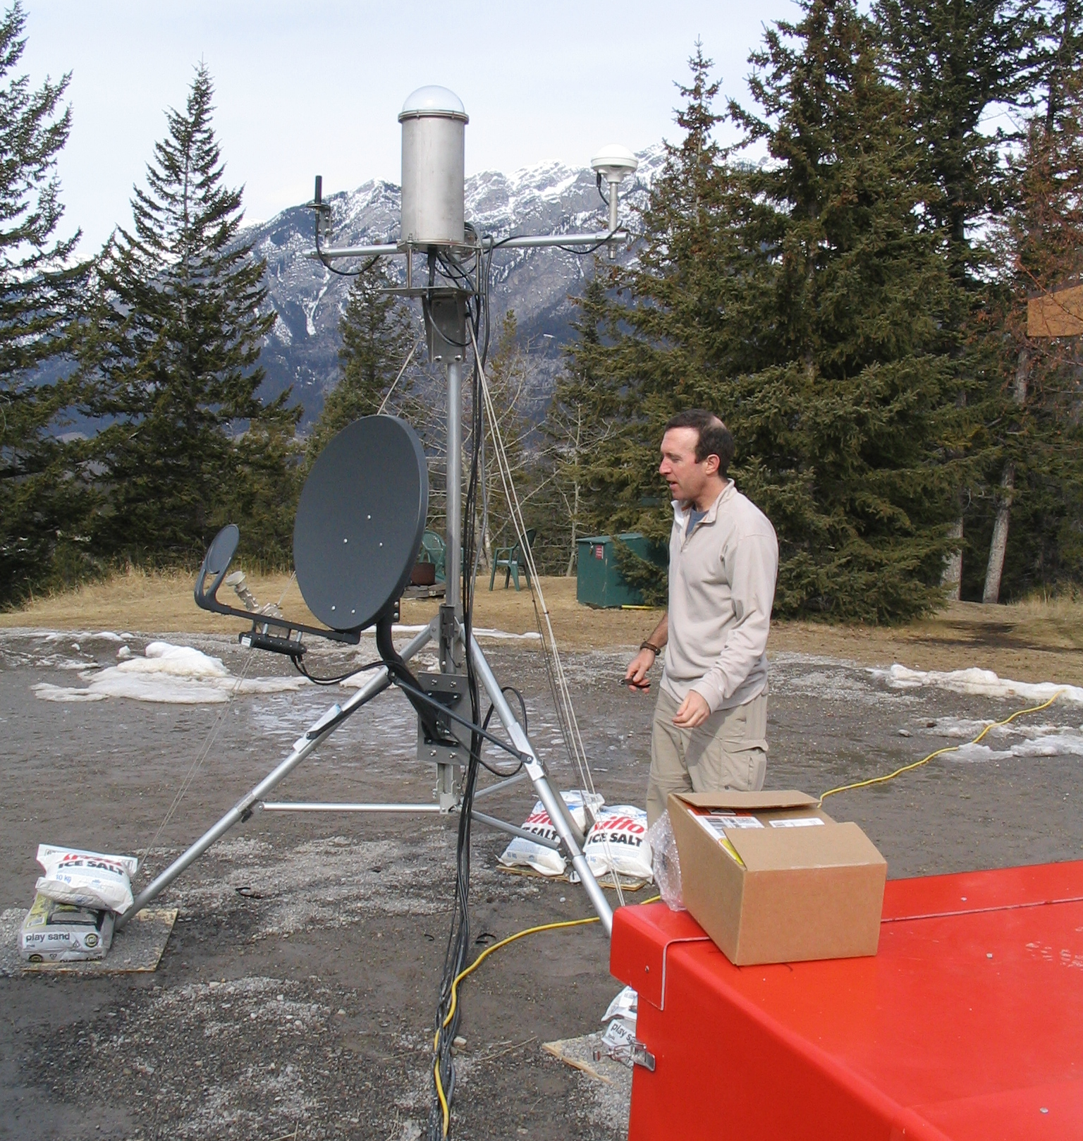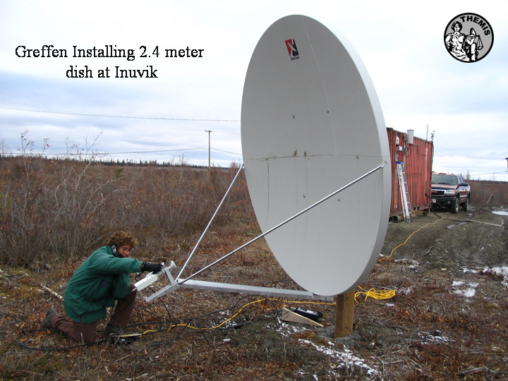

Figure: Left) Tim Quinn from UC Berkeley standing by the THEMIS GBO deployed temporarily at Banff in March 2006. Te grey dish on the trip pointing away from Tim is the 64 cm Ka-Band system marketed as “HSe” by Infosat and “Netkaster” by Netkaster. Right) Mike Greffen installing 2.4 meter HSi dish and electronics at the PolarDARN facility in Inuvik.
To: the SVG, Brian Jackel, David Milling, Mike Greffen, Mikko Syrjäsuo, Bill Gryba, Ron Wilkinson, Genevieve Gratton, William Liu, and Thomas Piekutowski

I will pursue this with Telesat directly, but it appears they have made a business decision to sell the Ku-Band currently allotted to HSi under a more lucrative system to more hungry customers. The only hope I have for reprieve is that this deadline could slip, with some pressure, to July 2007. That would allow us to accomplish a refit with no unscheduled and unbudgeted trips.

SED has 13 CGSM core sites with HSi installed and operating. U Calgary has six THEMIS sites with HSi installed and operating. U. Calgary must install an additional four THEMIS sites this fall, several of would have had HSi systems.

SED has already been to some sites this year (Bill – seven?). I guess seven, which means a refit this summer means seven unplanned and unbudgeted trips for SED to CGSM core sites (regardless of what path we choose). Not counting the cost of new equipment, this means that CGSM and/or SED will have to absorb a one-time hit of ~7 field trips. I do not know what SED field trips cost, nor what contingencies are built into the SED contract, so I can’t comment on the magnitude of this.

Bottom line for THEMIS: THEMIS has six sites with HSi already out there, so we need to make four unplanned trips (I anticipated that we would need to go to some for other reasons – so say 4 unnecessary trips is what this is going to cost THEMIS-Canada. These trips are not that expensive (possibly averaging 3-4k$), so this is a one-time only hit of 15k$, not counting equipment changes (which are minimally expensive). We have a small contingency budget, so this amount hurts, but this is the kind of contingency we imagined happening so we have to live with it and can. Based on a similar analysis to what is presented below for CGSM, we will make that back in cheaper bandwidth in less than 18 months (if we go Ka-Band). In other words, this is a revue neutral solution within our current contract (18 months from now we will have spent what we were expecting to spend. By three years from now, we will be well ahead.)

In my opinion Infosat has dealt with both SED (CGSM) and UCalgary (THEMIS) in bad faith in this instance. I do not believe they did not know this was coming. Mike Greffen has installed an HSi within the last six weeks, several this summer, and SED was already making the rounds. Knowing this even three months ago would have saved CGSM and THEMIS tens of thousands of dollars. Furthermore, in recent years, for several reasons, the U Calgary group has been growing frustrated with Infosat. They are often unclear in their communication (such as incorrect specifications on physical dimensions of the mountings), have made critical errors (such as shipping faulty modems and other components), and generally are not really on the ball with technical information (such as where certain dishes and systems will work).

That is the background - We need an alternative to HSi now. We have asked Brian and Bill to explore the Infosat specific “Connect” system, as well as the more generally available Ka-Band satellite service (marketed by Infosat as “HSe”, by Netkaster as “netkaster”, Telebec as simply “High Speed Internet Service”).

Bill and Brian will assess whether both systems will satisfy our technical needs. We should presume they both work. We should understand that Connect is a more or less seamless transition, but after today I am convinced it is an expensive option. Plus – it leaves us still dealing with Infosat. We should understand that there is one technical problem with Ka-Band, and that is “dynamic IP”, but it is MUCH cheaper to implement, and moves us towards being independent of being caught the way we are now.

I spent today on the phone with Infosat, Netkaster, and Bill Gryba, plus discussing options with Brian. I think I am in a position to comment on this in a general way. We still need Bill and Brian to make sure both systems are viable options for CGSM (we know they are viable for THEMIS-Canada).

Connect – The system uses the same antenna as HSi. We swap out the model, receiver, etc, for the new ones. We get the new hardware for 1500$ (it sells for 4300$ with a satellite dish, but the dish is a cheap part of the system), and can get bandwidth for 200$ per month signing a three year lease, 400$/month for a one year lease. We get to keep the dishes, plus this allows CGSM to skeep using static IP. We also have a firm guarantee of sustained uplink of ~4 kbits/sec for the HSi 500 package (good for most sites). The connect system will work where the HSi system does/did, so will work at te sites where it is currently deployed). Note also there is a “zero cost” option, where we get the Connect hardware for “free”, but sign on to a three year plan at 250$/month (rather than 300$/month).

Ka-Band – The system costs 750$ from Infosat, 495$ from Netkaster, and in that range from other distributors. That includes the new antenna which is only 64 cm across. This uses dynamic IP, and has no quoted bandwidth limits (just maximum instantaneous bandwidths), but has a “fair use” policy which allows them to throttle users back if they are being bandwidth hogs. Given their caps are high (128 kbits per second for their cheapest package), the salesperson said she expected this system should be able to deliver 10 kbits/second sustained, but she is checking on that for me. The cost of service is 59.95$/month for their cheap bandwidth package, and we can sigh up for a one year package, but say we pick three years for fair comparison below. As well – and this is surprising – the Ka-Band system works up to 73.5 degrees geographic latitude (there is a system operating in Pond Inlet), with only a 64 cm dish. Our behemoth 2.4 meter dish at Inuvik could be replaced by a 64 cm dish! Same for Contwoyto, etc. That is a huge advantage (see figures on front page).

Note that while Netkaster is balking at us being able to deploy the Ka-Band ourselves (for the same reason Infosat originally said it wouldn’t let us do that), I got the feeling they would bend on that. Further, they have distributors in MANY of the towns we are in so deployment by them would be cheap, and service visits REALLY cheap. For example, a service visit in Arviat would cost 120$ if it was OUR FAULT, and less if it was, for example wind. Regardless, I want to proceed with the assumption that we will have the option of doing our own deployments or using for example Netkaster (if that is cheaper which it sometimes will be).

Provided Ka-Band works, and provided Brian can sort out the difficulties of going to dynamic IP, I am recommending that we seriously consider going to the new Ka-Band system for CGSM (I think we have already decided for THEMIS). My reasons are (briefly):

- Infosat has really let us down here. Further, they are less than broken up about this (both Bill and I get that impression), which frightens the hell out of me if we go with them again, for a system that only they sell (there is no other vendor for Connect). So I am thinking we should be open to looking elsewhere.
- Provided Ka-Band works, and we can get the dynamic IP issues worked out, then Ka-Band will save us money. Excluding installation costs (ie., for hardware and bandwidth) I estimate the Connect solution costs us ~100,000$ more in total over three years if we do not take the “zero cost” option, which is less economical. I am assuming that installation costs will be more or less the same.

Bottom line for CGSM: If we go with Connect we will spend 100,000$ (or so) more over the next three years than if we go with Ka-Band. As Brian said to me this evening “that is a lot of money to pay for static IP”. Another way of looking at this: Over the next three years we were expecting to spend 135000$ on telemetry (13 sites for 3 years, 3 additional for two years, 250/month bandwidth cost). With Connect, over the next three years we will spend instead 175,000$ (telemetry at 200$/month, plus new hardware, plus 40k$ excess travel). With Ka-Band, we will spend a total of 75,000$ (telemetry at 60$/month, plus new hardware, plus 35k$ excess travel). So going Ka-Band, we will spend 60,000$ less than we were going to spend anyway, and 100,000$ less than if we go Connect.

The basis for the cost calculation is as follows (the idea is that costs – including unexpected travel – are integrated over three years).

Estimate of costs of two options, integrated over three years for the 13 existing and 3 new CGSM core sites.
system |  | # of | # of | hardware | bandwidth per | Totals
 |  | sites | months | per site | site per month
Connect | existing sites | 13 | 36 | 1500 | 200 | 113100
Connect | new core sites | 3 | 24 | 4300 | 200 | 27300
Connect | excess travel |  |  |  |  | 35000 | 175400
Ka-Band | existing sites | 13 | 36 | 495 | 60 | 34515
Ka-Band | new core sites | 3 | 24 | 495 | 60 | 5805
Ka-Band | excess travel |  |  |  |  | 35000 | 75320
Current Path | existing sites | 13 | 36 | 0 | 250 | 117000
Current Path | new core sites | 3 | 24 | 0 | 250 | 18000
Current Path | excess travel |  |  |  |  | 0 | 135000

Reference Table: CGSM Core Sites & THEMIS GBOs [✓=deployed, =planned].

Name | Abbreviation | Latitude | Longitude | THEMIS | CGSM | Urgent
Athabasca | ATHA | 54.72 | 246.72 | ✓
Chibougamau | CHIB | 49.50 | 285.80 | ✓ |  | T
Contwoyto Lake | CONT | 65.75 | 248.75 |  | ✓ | C
Dawson | DAWS | 64.05 | 220.89 |  | ✓ | C
Ekati | EKAT | 64.57 | 250.00 | ✓ | 
Eskimo Point (Arviat) | ESKI | 61.11 | 265.95 |  | ✓ | C
Fort Chipewyan | FCHIP | 58.70 | 248.87
Fort Churchill | FCHU | 58.76 | 265.92 |  | ✓ | C
Fort McMurray | FMCM | 56.66 | 248.79 |  | ✓ | C
Fort Simpson | FSIM | 61.76 | 238.77 | ✓ | ✓ | CT
Fort Smith | FSMI | 60.02 | 248.05 | ✓ | ✓ | CT
Gillam | GILL | 56.38 | 265.36 | ✓ | ✓ | CT
Goose Bay | GBAY | 53.32 | 299.54 | ✓
Inuvik | INUV | 68.30 | 226.70 | ✓ |  | T
Island Lake | ISLL | 53.85 | 265.33 |  | ✓ | C
Kapuskasing | KAPU | 49.42 | 277.57 | ✓ |  | T
Nain | NAIN | 56.53 | 298.24 | ✓ |  | T
Pinawa | PINA | 50.25 | 263.96 | ✓ | ✓ | CT
Prince George | PRGE | 53.55 | 237.51 | ✓ |  | T
Rabbit Lake | RABB | 58.22 | 256.32 |  | ✓ | C
Rankin Inlet | RANK | 62.82 | 267.89 | ✓ | ✓ | C
Sachs Harbor | SACHS | 71.98 | 234.77 |  | 
Taloyoak | TALO | 69.54 | 266.45 |  | ✓ | C
The Pas | TPAS | 53.97 | 258.90 | ✓ |  | T
Umiujaq | UMIU | 56.50 | 283.50 | ✓ |  | T
Whitehorse | WHIT | 60.72 | 224.95 | ✓
Note “urgent” means we HAVE to do something this year to mitigate data loss. In that column “C” and “T” mean urgent for CGSM and THEMIS, respectively.

