NORSTAR Science Analysis Plan

Eric Donovan

Version 1.0 – May 2005

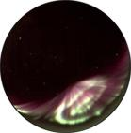
Introduction

The NORSTAR instruments deliver optical and radio data that can be used to infer properties of the precipitating electron and proton populations.

NORSTAR optical data consists of images from three types of ASI. These are the Keo Sentry, and two types of Starlight Express imagers. We are the historical archive for other ASI data sets (Wilbur, POCA, etc), and are negotiating with other programs (MIRACLE and Alaska for example) to house at least their summary data. The ASI data sets are traditionally large (tens of GBytes for Wilbur, which is in fact a small data set).

NORSTAR MSP data consists of two streams from the same instruments. These are the so-called “high res” and “low res” streams. We are a historical archive for the MSP data from the CANOPUS era. We will be freezing the historical archive, storing it on DVD, and shipping it to the CSA for safekeeping. The MSP data sets are a medium volume set.

NORSTAR riometer data is a low volume data set. This is a 5 second cadence, one dimensional data stream from each of 13 instruments. We are, however, involved in the worldwide GLORIA program, and will likely be merging this data set with those from other riometer chains over the next few years.

NORSTAR (including appropriate historical) data sets are organized and stored on “aurora” (see aurora.phys.ucalgary.ca – our web page is currently under development). A document outlining our historical CANOPUS archive at U. Calgary (on aurora) is included with these reports. We are preparing a larger data availability document that will include the ASI data from all of NORSTAR, Wilbur, POCA, Rainbow, and other instruments. That will follow in several months time.

Our philosophy is that analysis of NORSTAR data must 1) facilitate qualitative interpretation of the data as well as quantitative studies; 2) be consistent with state-of-the-art techniques used in other programs (ie., such as MIRACLE or UNIS); 3) analysis of NORSTAR data must support integrated use of NORSTAR data with that from other CGSM program elements.

In this document we treat each of the three data types separately. We finish with our plans for further development of the data.

The scientific units from which geophysical quantities are derived are Rayleighs (for the optical data) and dB absorption (for the riometers). Both are difficult units to extract from such data. We will have an ongoing program to improve our understanding of the extraction of these units from our data sets.

Riometer

The riometers infer precipitation of high energy electrons and protons via their effect on ionization in the D-region and subsequent absorption of HF cosmic noise. The riometers are proving to be a robust way of tracking the spatio-temporal evolution of injected plasma during the substorm expansive phase on an essentially global scale. The riometers that have been run as part of CANOPUS and now as part of CGSM were ignored by the scientific community until around 2002, when Emma Spanswick, Brian Jackel, and Eric Donovan began a series of statistical and event studies using this data. This team has developed background subtraction techniques. Those techniques are presently being applied to the entire riometer data set. That work will be mostly complete by the end of May 2005.

The riometer data is being developed as a coarse image of high energy precipitation. Used with data from other riometers worldwide, this technique is competitive with X-Ray imagers on satellites, and much more cost effective. Further, the riometers are able to provide much better temporal resolution.

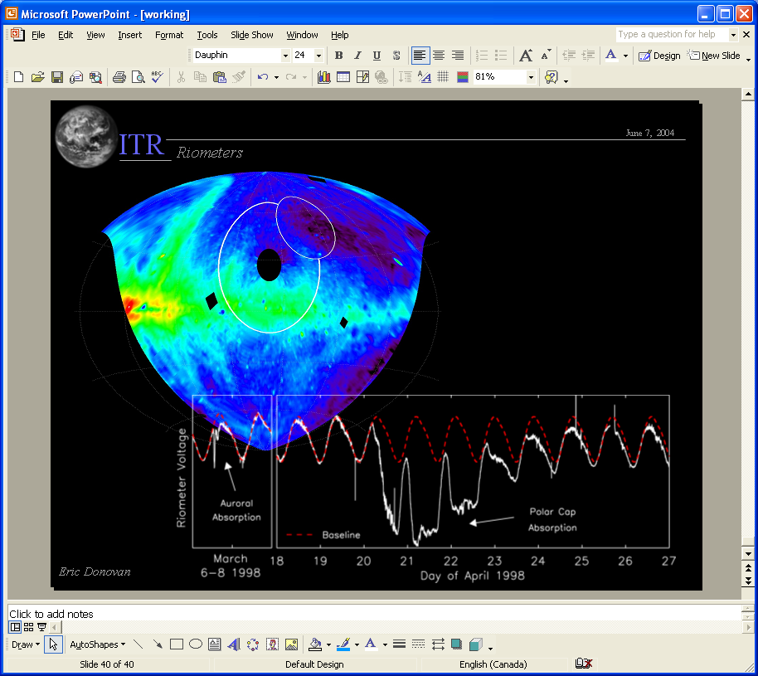

Figure: Cosmic radio background in celestial coordinates (at 22 MHz from a DRAO survey courtesy Tom Landecker) and the path swept out by a riometer at Pinawa over one sidereal day. At bottom we show two types of absorption (deviations from the quiet day curve) due to substorms (injected electrons) and a polar cap absorption event (solar protons) [note figures produced by Brian Jackel and Emma Spanswick].
The analysis plan for the riometers is very straightforward. We are going to continue baselining the riometer data using techniques developed in house. We are going to build up an almost twenty year data set of absorption from the 13 sites. We are going to create summary plots, and CDF files for quick access to the data. We are going to develop a web-based tool for quick access to the data. We are going to work with members of the international riometry community to develop GLORIA – the Global Imaging Riometer Array. This will involve merging this data set with those from other arrays. We are hosting the second international riometry workshop in Banff in March 2006 (just prior to the substorm meeting). We anticipate that for the near future, the riometer data will be used in conjunction with data from other instruments in event studies. An example that will be in an upcoming paper by Spanswick et al is the following.

Figure: Stack plot of MSP, fluxgate magnetometer, GOES magnetic inclination, filtered fluxgate magnetometer (showing Pi2 activity), in conjunction with riometer absorption showing substorm “spikes”. The spike is clearly related to current disruption. Future scientific work will be aimed at elucidating the relationship between the spike, disruption, and other expansive phase onset features.

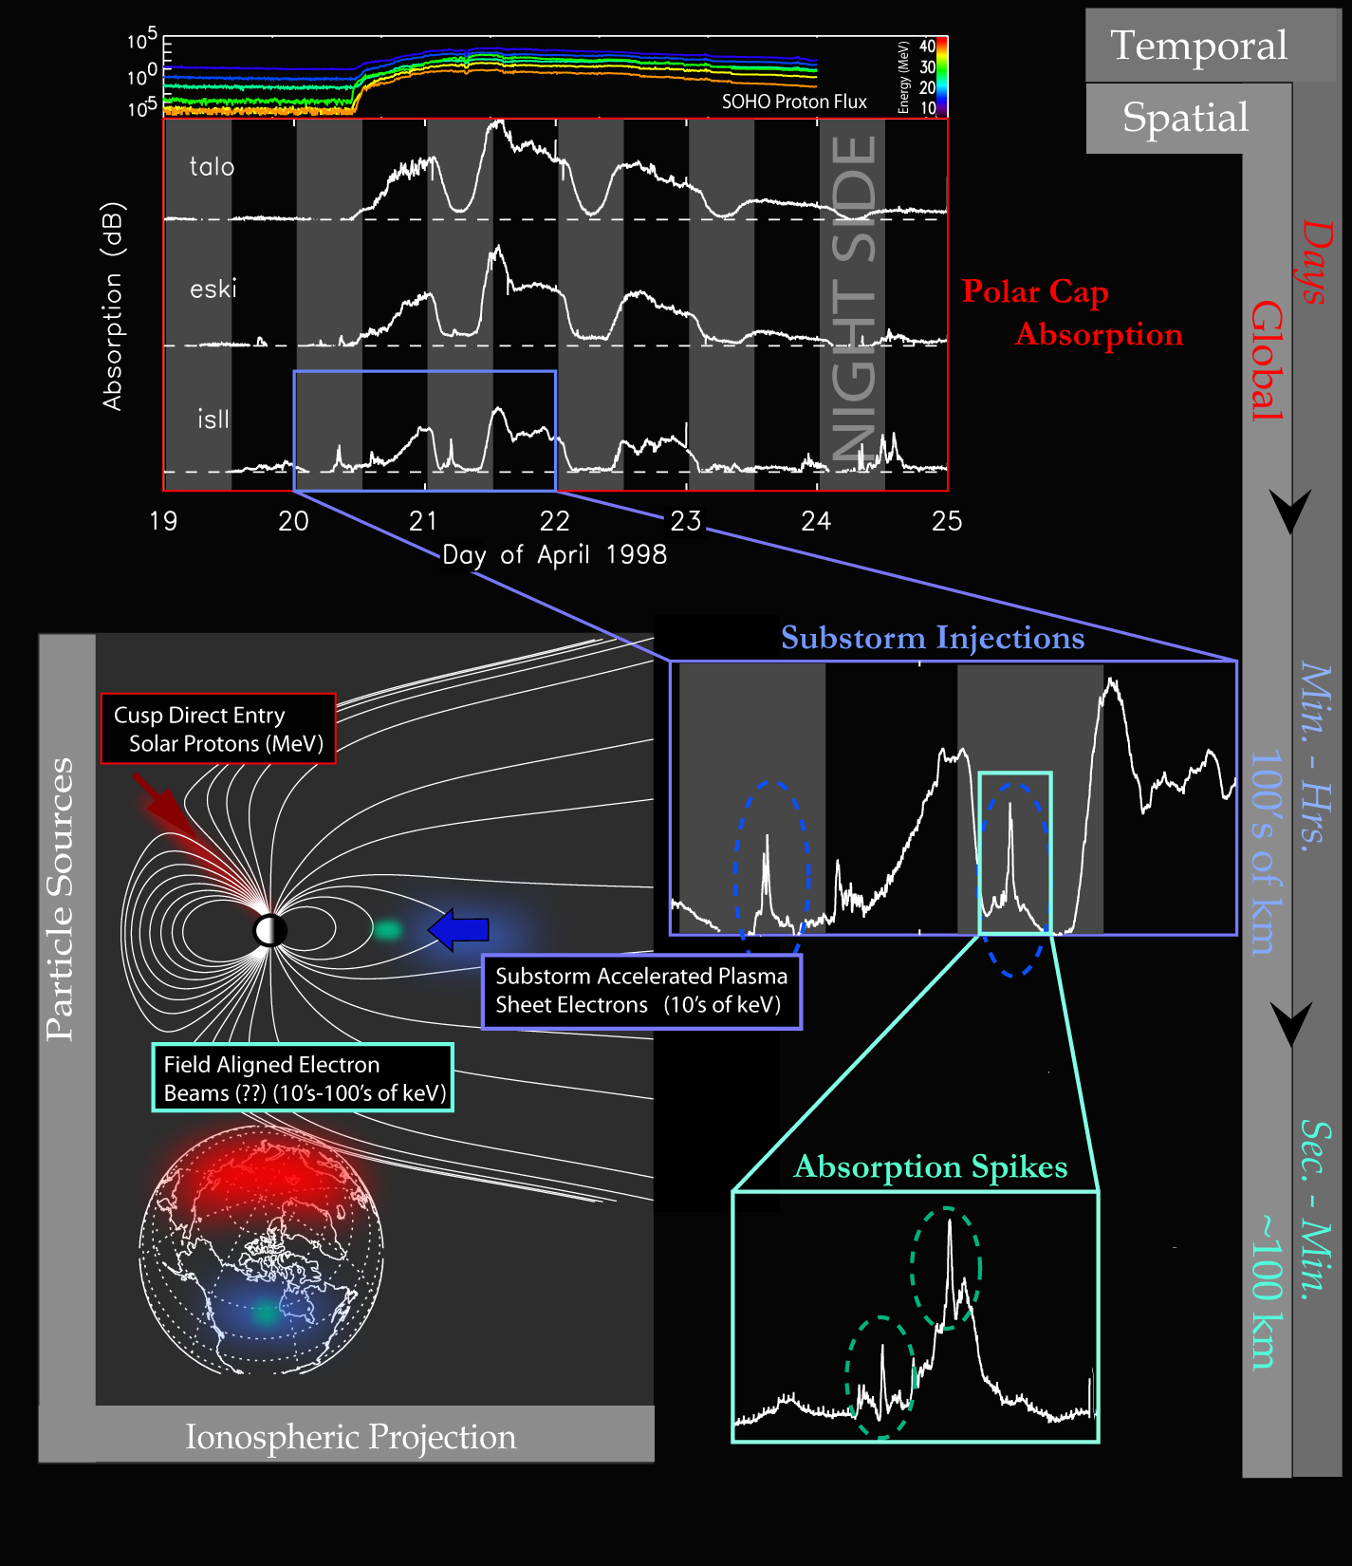

Figure: The riometers allow us to study fast local processes like the dispersionless injection as well as global processes such as the dispersed injection and polar cap absorption events. The objective of our analysis program is to support studies of local and global scale phenomena.
Meridian Scanning Photometer (MSP)

The MSPs deliver high and low resolution data. The MSP data has been widely used in support of magnetospheric and ionospheric studies. The MSP data has traditionally been more quantitative than that produced by ASIs, although that situation is changing.

The low resolution MSP data is used to track boundaries and other features of the electron and proton aurora. For example, the poleward border of the 630 nm emissions has been shown to be a good proxy for the open-closed boundary in the evening sector [Blanchard et al., 1995]. As well, the equatorward boundary of the proton aurora is an excellent basis for an optical magnetotail index [Donovan et al., 2003]. The high resolution data is excellent for quantitative studies of structured electron auroral features [see eg., Lyons et al., 2002].

We have developed readfile routines for the MSP data, and summary plots for use on NORSTAR-Web and the SSDP. For example, the following is a summary of 486 nm data from the four MSPs on February 19, 1996. After that, we include a summary of the three relevant wavelengths on the Churchill Line (note we are not using the 471 nm data at present – although we will address that in the future).

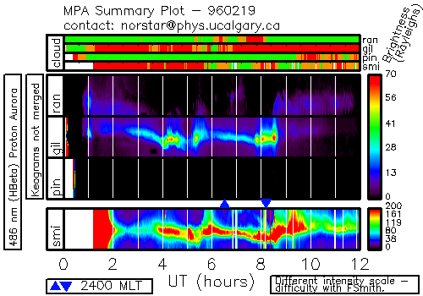

Figure: MSP summary plot for NORSTAR-WEB and SSDP. Note that the brightness at Fort Smith is clearly incorrect. Further, note that the cloud index indicates clouds over Gillam when it is clear there.

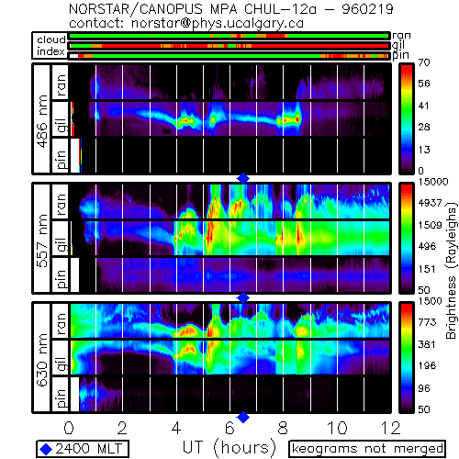

Figure: Stack plot of keograms from the Churchill line stations for the three relevant wavengths.

Our analysis plan over the next eighteen months is as follows:

- develop and/or implement boundary identification for poleward and equatorward boundaries of H-beta and 630 nm data.
- understand background subtraction, aerosol correction, and other corrections applied by Creutzberg data.
- develop algorithms to separate electron induced and proton induced aurora.
- develop triangulation techniques for overlapping fields of view.
- develop a statistical “fix” for the Fort Smith brightness.
- carry out a manual survey of the entire data set in order to identify periods of “excellent viewing”.
- develop CDF files for the low resolution data.
- produce an online archive of the high resolution data.
All Sky Imagers

The ASIs are the most difficult instrument to deal with in the NORSTAR program. They produce staggering amounts of data. That data is difficult to analyze because of technical issues. These issues include the fat that CCD imagers have not been well calibrated historically, and the optics impose an effective sensitivity that depends strongly on position in the image (or on the CCD/focal plane). The fundamental data product from the All-Sky Imager are images. The following panel plot consists of four images that show auroral arcs. These are from the “Wilbur” data set. These images are monochromatic (collected though a narrow bandpass filter centered on 557.7 nm).

The Wilbur data typifies monochromatic images. Searching through large image data bases is cumbersome, so it has become common to summarize this data using keograms (the type of plot used to show the MSP data above). The keograms are a plot showing brightness (color or shade) vs latitude and UT. The keograms are typically constructed using the middle column from the CCD (or co-added several columns). The following figure illustrates the production of a keogram.
Figure: Keogram constructed from image sequence. Some images that contributed to the keogram are included. The red line indicates that part of the image that contributed to the keogram. Note that in the keogram, phase velocities are easily determined (speeds given assuming 300 km altitude). Figure prepared by E. Donovan and published in Rankin et al., 2003].
The operational objective of NORSTAR is to provide continent-scale maps of auroral luminosity in support of research on the five CGSM science themes. The following keogram illustrates that we are at least part way to meeting this objective (although our imagers have not operated on a consistent basis). The stack plot shows 630 nm data from four stations along a magnetic meridian. WE have coverage from inside the polar cap, to well equatorward of the equatorward boundary of the electron aurora.

Figure: keograms showing coverage of aurora from inside polar cap (note drifting patches) to equatorward of the auroral oval. The top three keograms are from NORSTAR ASIs, while the bottom keogram is from the photometer at Pinawa.

We are in the process of developing a summary plot browser for the ASI data. An example is shown below. Please try out the browser at http://aurora.phys.ucalgary.ca/cgi-bin/browser1a.pl?

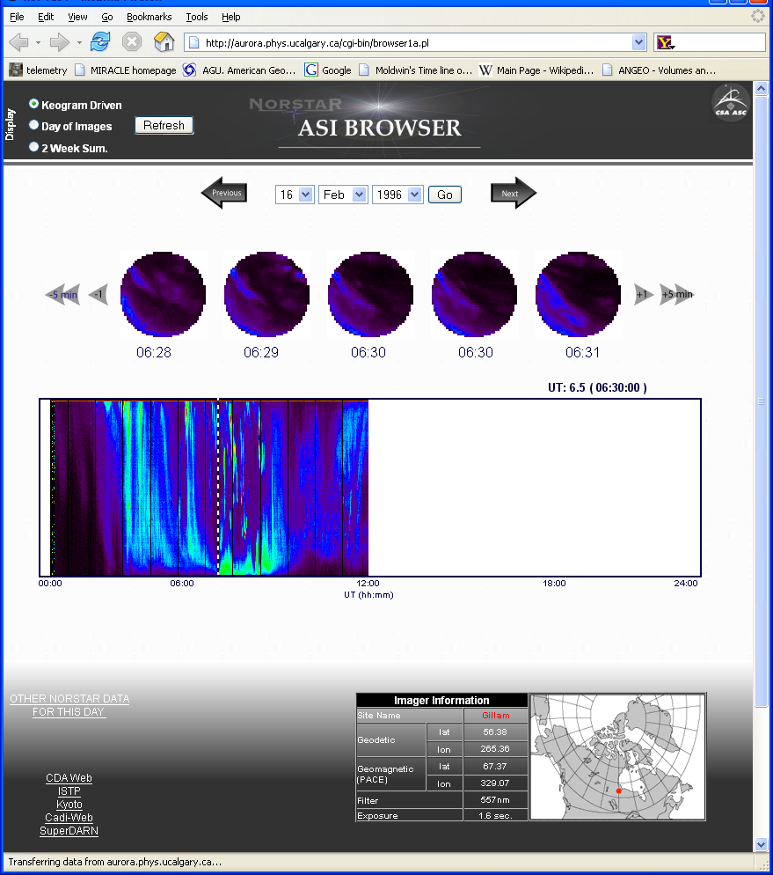

Figure: ASI summary browser on NORSTAR-WEB. This is in development, but allows one to search an image data base by date, and to pick sets of summary images by clicking on a keogram or by using buttons to scan forwards and backwards. This will be utilized for all NORSTAR ASI data.

The summary data browser allows one to select days from two week summary plots. These are stack plots of keograms for successive days (see below).

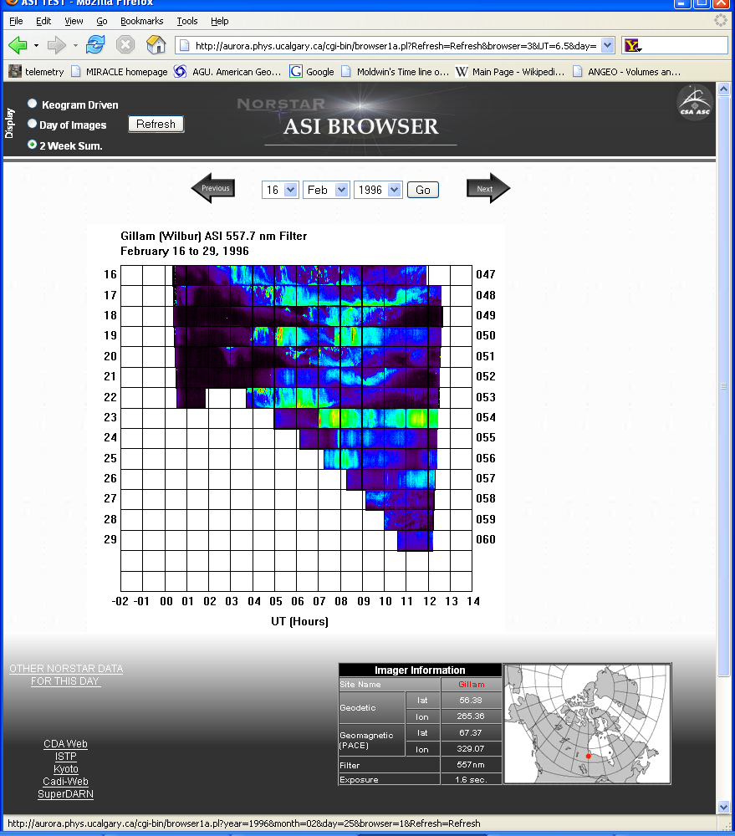

Figure: Summary keograms showing two weeks of image data.

We will be developing a similar data product for showing data from all imagers on a single night on one plot.

Our ASI analysis plan for the next eighteen months is

- create mosaics for real-time display of multiple image data sets
- implement mosaics on NORSTAR-Web (basis for GAIA)
- develop corrections for vignette effects
- develop and implement automatic orientation detection
- develop systematic approach to converting from CCD to celestial coordinates
- test the viability of using ASI data to determine geophysically meaningful boundaries
- explore the use of full-color images to carry out quantitative auroral work
- develop optical flow techniques for inferring velocities from images
- implement machine vision techniques
- organize the data set online
- develop effective summary plots

Overall

The above analysis work treats data from each instrument separately. The end goal for CGSM is integration. The optical data should be utilized with magnetometer, riometer, HF-radar, and CADI data to provide a detailed picture of ionospheric electrodynamics on the mesoscale. This work is ongoing, and will forever be a part of the activity of all CGSM program elements. We anticipate that in the next year or so, we will focus on the integrated use of SuperDARN and NORSTAR optical and riometer data. Even more specifically, work has begun on comparing substorm auroral features with convection, exploring the relationship between the auroral structures and field-aligned currents, and that between bursty bulk flows and distant tail reconnection.

